**Probability and Statistics**

**Lab-7**

**IT24100860**

**Fernando S.K**

**Exercise**

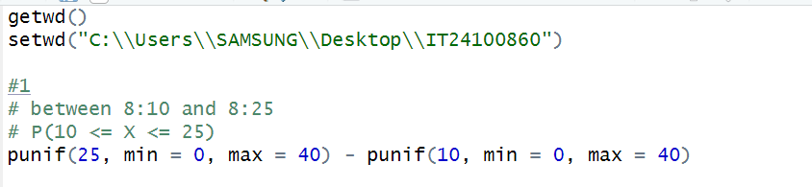

1. 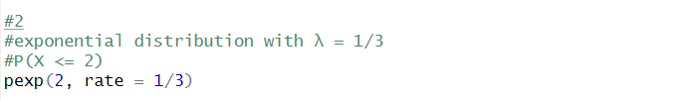

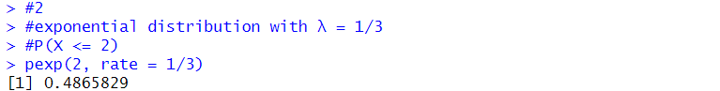

1. 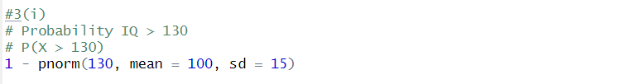**I)**

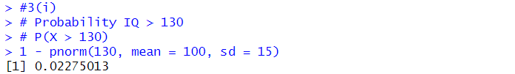

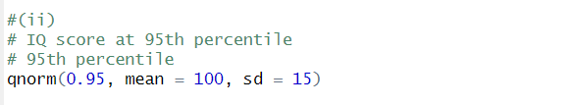**ii)**

